Lab Assignment 4

Chaudhary Hamdan

1905387

Date: 09-02-2022

Question:

1. A sphere has radius equal to 6, calculate its the volume . An approximate value would do.

r = int(input("Enter radius: "))

vol = (4*22*r*r*r)/(3*7)

print('Volume:', vol)

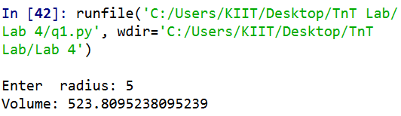

1. The marks obtained by a student in Physics, Chemistry,English and Maths are 92, 72, 83, and 65 respectively.Add 5 marks to science subjects and find the average marks obtained by him.Calculate the grade using if else statement.

p, c, e, m = 92, 72, 83, 65

p += 5

c += 5

def grade(m):

ans = 'F'

if m >= 90:

ans = 'O'

elif m >= 80:

ans = 'E'

elif m >= 70:

ans = 'A'

elif m >= 60:

ans = 'B'

elif m >= 50:

ans = 'C'

elif m >= 40:

ans = 'D'

return ans

print('Physics grade: ', grade(p))

print('Chemistry grade: ', grade(c))

print('English grade: ', grade(e))

print('Maths grade: ', grade(m))

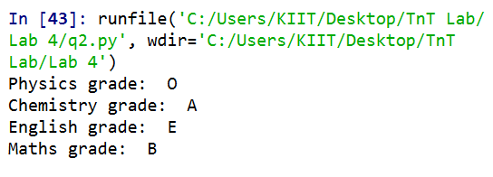

1. Write a program which uses a person_age to print number of years left for retirement (a person retires at 65). You can ask the age from the user as well

age = int(input("How old are you? "))

print(65-age)

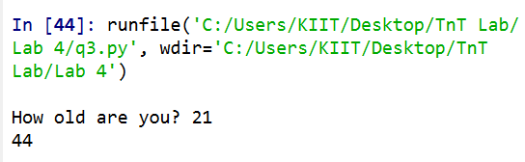

1. A student campus has got 3 divisions of girls and 5 divisions of boys. Write a program which asks the user to input number of boys and girls in each division using for loop.

• It should print

• number of girls,

• number of boys

• total number of students.

Sections:3 for girls A,B,C

Section :5 for boys A,B,C,D,E

gd, bd = 3, 5

ng, nb = 0, 0

for i in range(gd):

ng += int(input(f'Girls in {i+1} grp: '))

for i in range(bd):

nb += int(input(f'Boys in {i+1} grp: '))

print('Total girls =', ng)

print('Total boys =', nb)

print('Total students =', (ng+nb))

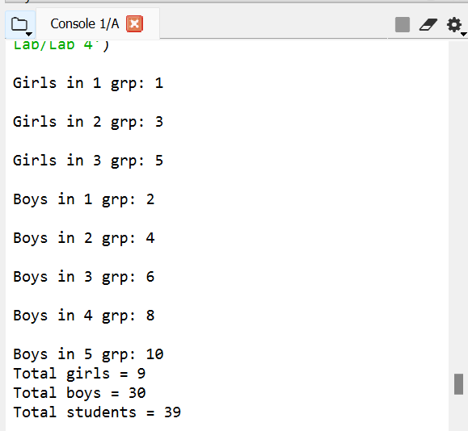

1. Write a Python program that prompts the user for his/her amount of money,then reports how many jean pants the person can afford, and how much more money he/she will need to afford an additional jean pant (cost of jean pant = need to afford an additional jean pant. (cost of jean pant = 750)

money = int(input('Enter money: '))

jeans = money // 750

additional = ((jeans + 1) * 750) - money

print('Jeans can be bought:', jeans)

print('Money for additional jean: ', additional)

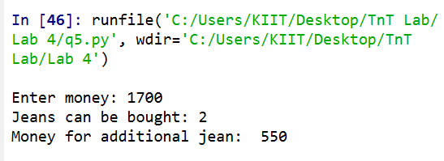

1. a) Write a program which converts 13 hours and 32 minutes into

seconds.

WAP to convert given second into its equivalent hour, minute and second as per the following format. Ex. 8860 second = 2 Hour, 27 Minute and 40 Second

hrs, mins, secs = 2, 27, 40

secs += (hrs*3600) + (mins*60)

print('Seconds:', secs)

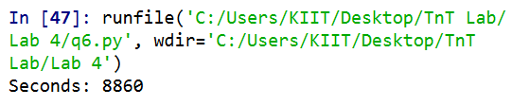

1. WAP to find the roots of a quadratic equation ax2 +bx+c=0 using if-else statement.

a, b, c = map(int, input('Enter a, b, c: ').split())

d = b*b - 4*a*c

if d < 0:

print('Imaginary roots')

elif d == 0:

r = -b / (2*a)

print('Real and equal roots:', r)

else:

r1 = (-b + (d**0.5)) / (2*a)

r2 = (-b - (d**0.5)) / (2*a)

print('Real and different roots:', r1, 'and', r2)

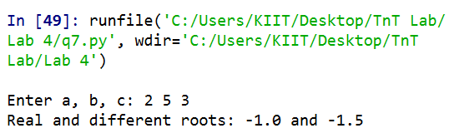

1. WAP to check whether a number n is prime number or not.

n = int(input('Enter number: '))

c = 0

for i in range(2, n):

if n%i == 0:

c += 1

break

if c != 0:

print('Not prime')

else:

print('Prime')

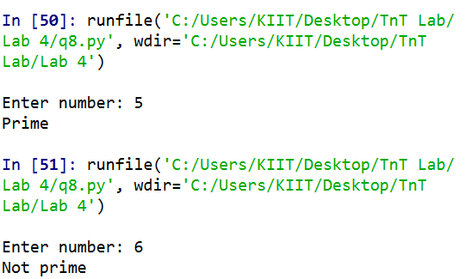

1. WAP to find the first n numbers of a Fibonacci sequence.

n = int(input('Enter n: '))

a, b = 0, 1

if n == 1:

print(a)

elif n == 2:

print(a, b)

else:

print(a, b, end=' ')

for i in range(n-2):

a, b = b, a+b

print(b, end=' ')

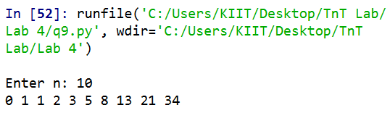

1. WAP to calculate the factorial of a given number.

n = int(input('Enter n: '))

f = 1

for i in range(2, n+1):

f *= i

print('Factorial=', f)

